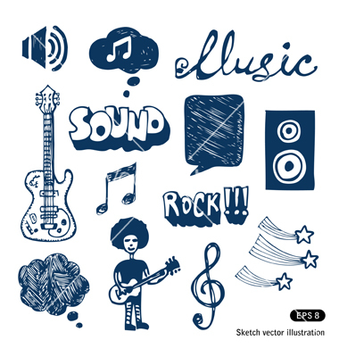
Elements of Music
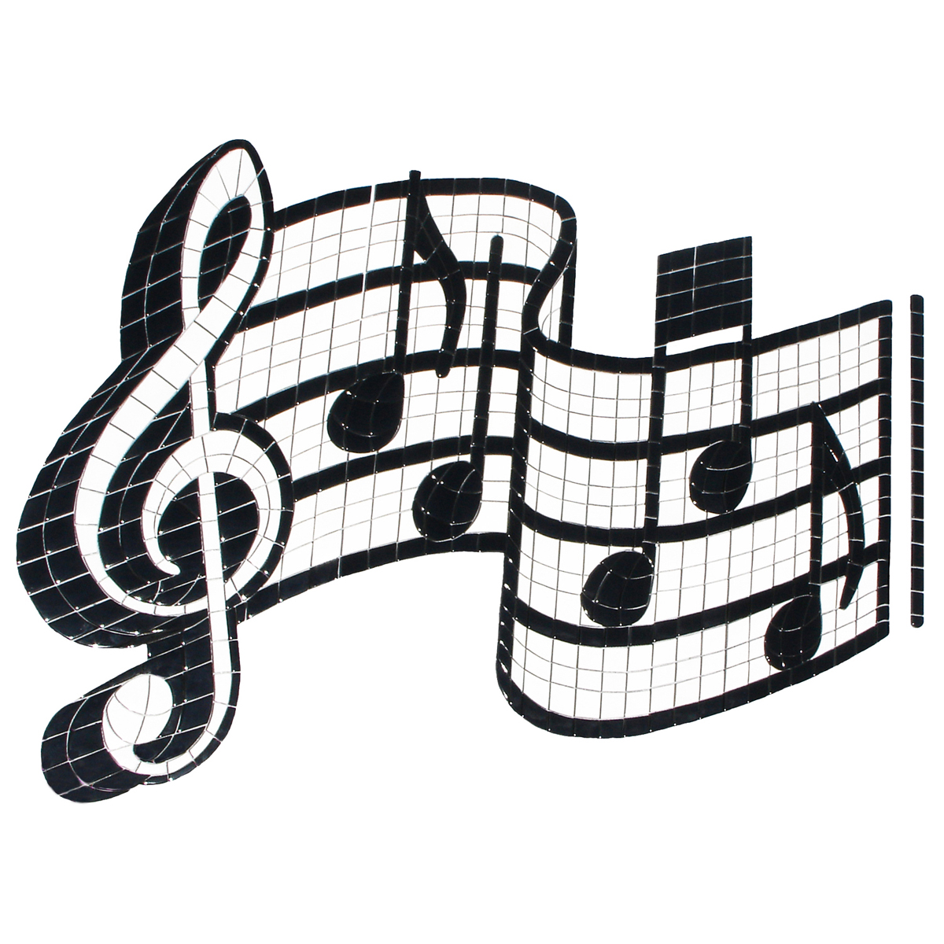
By: Lidya

Table of content
- Cover page
- Table of content
- Rhythm
- Dynamic
- Tempo
- Timbre
- Harmony
- FINISH!!
- Bibliography
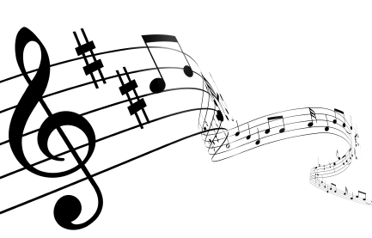

INTRODUCTION

This booklet is about the basic elements of music.

Here provides 5 music elements that are rhythm, tempo, dynamics, scales and harmony.

RHYTHM!

What is rhythm?

Rhythm came from a Greek language called Rhein which means flow. Rhythm in music happens when a note or chord begins and ends.

Rhythm is not just in music. Rhythm is everywhere in our daily life.

Rhythm has beats and it is made out of sounds and silence. These sounds and silence formed as a pattern which is repeated to create a rhythm

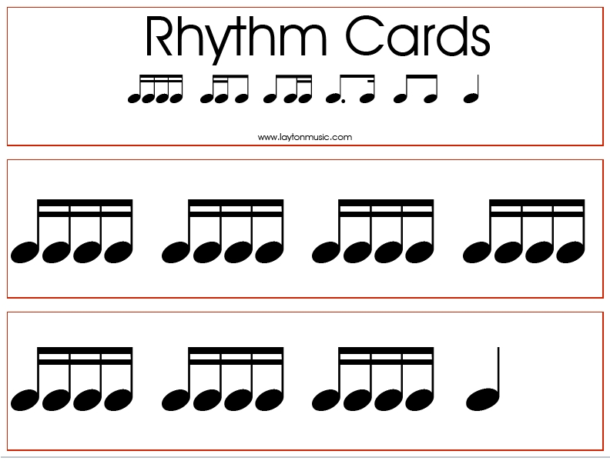

Dynamic

In music, there are symbols and signs.
The dynamics sounds are forte which means loud, mezzo forte which means medium loud, mezzo piano which means medium soft and piano which means soft. These are the dynamics for volume.

The changes in the volume also have a crescendo which means becoming louder, diminuendo which means becoming softer and sforzando which means making a sudden accent on a chord or note.
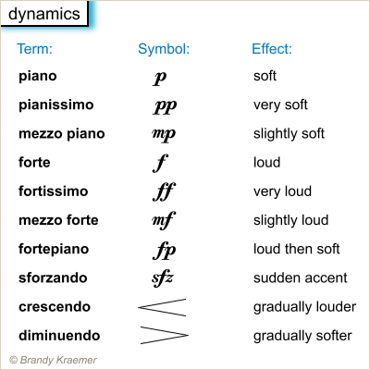
Tempo

Tempo?

Tempo is the speed of music.
It sounds like a pulse or a clock ticking. Tempo will influence how the music sounds or feels.
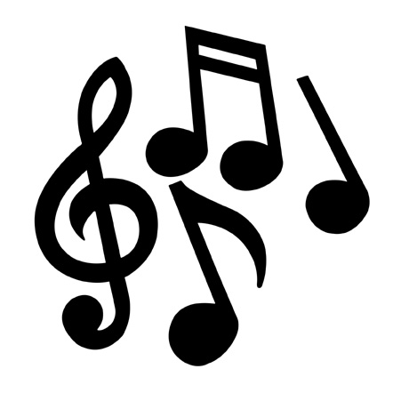
The metronome is a material used to have tempo while playing music.

Timbre Timbre

Timbre is also called color of music. Timbre is caused when an instrument has more than one frequent of tone.

There are instruments with a specific pitch and there are that have greater frequencies.
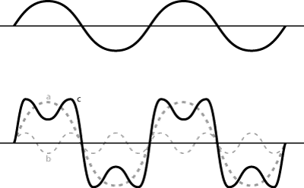
There are many words to describe timbre such as reedy, brassy, clear or harsh.

Harmony

Harmony and melody
Melody is a group of notes played one after another. Melody is the tune.

Harmony is also a group of notes but it is played behind the melody. It gives the music texture.
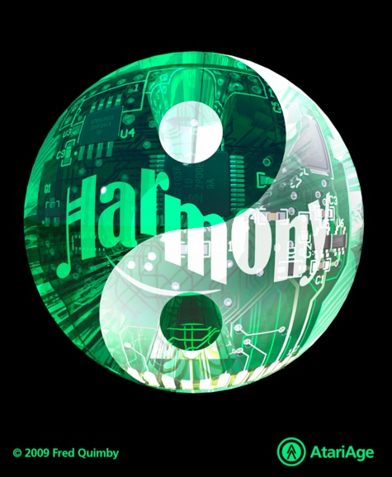

Last page!!

So? Did you learn anything about music?

Thankyou for reading this booklet.
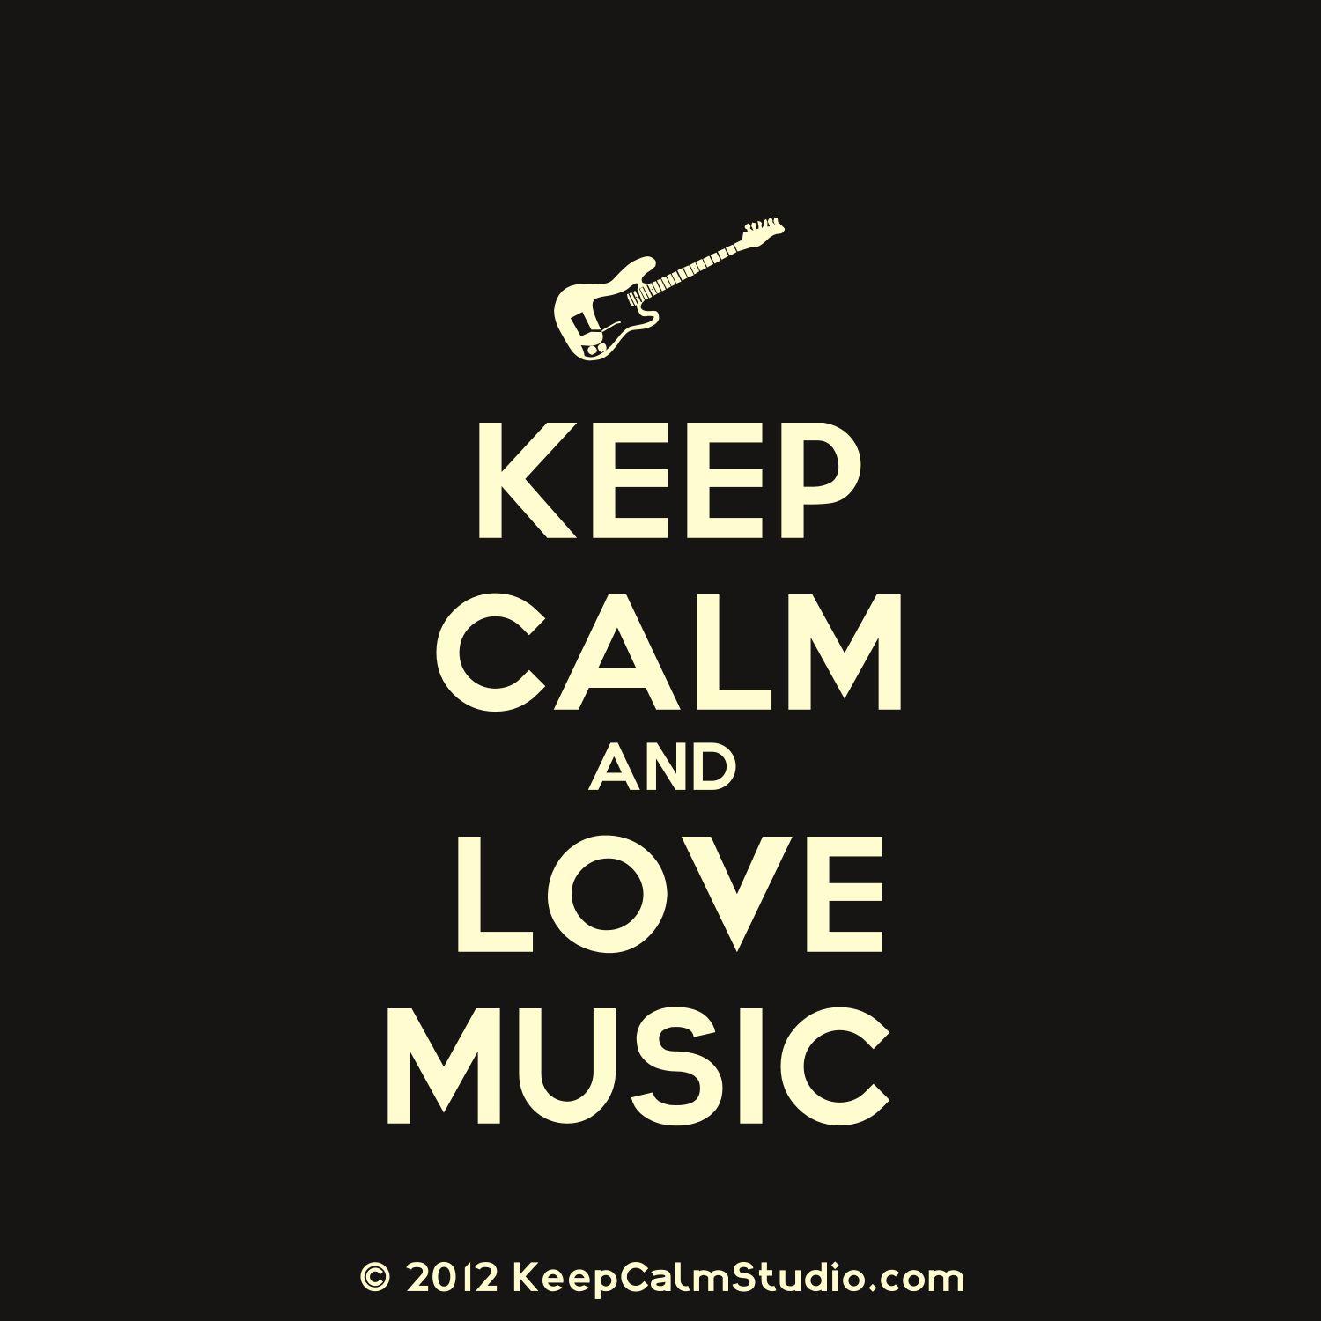

http://www.louisianavoices.org/unit6/edu_unit6w_msc_elements_chart.html
http://www.sfskids.org/templates/musicLabF.asp?pageid=12

http://www.talktalk.co.uk/reference/encyclopaedia/hutchinson/m0026648.html

http://www.sfskids.org/templates/musicLabF.asp?pageid=11

http://0.tqn.com/d/piano/1/0/m/G/-/-/musical-dynamics_MUSIC.png (pic)

http://cnx.org/content/m11059/latest/
http://www.sfskids.org/templates/musicLabF.asp?pageid=16

